Assignment (N+) Day-3(IPv4 & IPv6)
Task-1:
IPv4 Addressing | IPv6 Addressing
32-bit address length | 128-bit address length
Dotted-decimal format | Hexadecimal format
~4.3 billion total IPs | 340 undecillion total IPs
DHCP or manual setup | SLAAC automatic setup
Uses broadcast routing | Uses multicast routing

Task-2:
Laptop:
IP Address 192.168.10.10
Subnet Mask 255.255.255.0
Default Gateway 192.168.10.1
Phone:
IP Address 192.168.10.11
Subnet Mask 255.255.255.0
Default Gateway 192.168.10.1
Smart TV:
IP Address 192.168.10.12
Subnet Mask 255.255.255.0
Default Gateway 192.168.10.1
Printer:
IP Address 192.168.10.13
Subnet Mask 255.255.255.0
Default Gateway 192.168.10.1

Task-3:
Valid Subnets: 8
Usable Hosts per Subnet: 30
First Three Subnets:
- Subnet 1:
Network Address: 192.168.1.0
Usable Host IPs: 192.168.1.1 – 192.168.1.30
Broadcast Address: 192.168.1.31
- Subnet 2:
Network Address: 192.168.1.32
Usable Host IPs: 192.168.1.33 – 192.168.1.62
Broadcast Address: 192.168.1.63
- Subnet 3:
Network Address: 192.168.1.64
Usable Host IPs: 192.168.1.65 – 192.168.1.94
Broadcast Address: 192.168.1.95

Task-4:
Network Address: 10.0.5.0
Broadcast Address: 10.0.5.255
Valid Host Range: 10.0.5.1 – 10.0.5.254

Task-5:
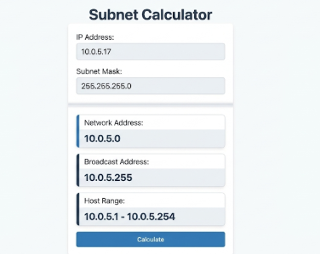
Yes, the manual calculation perfectly matches the tool's output, confirming the network address is 10.0.5.0, the broadcast is 10.0.5.255, and the usable host range is 10.0.5.1 to 10.0.5.254.

